Qualification Test Program

Customer | : | Flowserve Pompes Arnage
Ultimate User | : | EDF/NNB Hinkley Point C
Customer Reference | : | 232158
Pump Manufacturer | : | Flowserve FPD
Roosendaal Test Project | : | 2017RSD11TL
Seal type and size | : | QB-4000
Flowserve order no. | : | 873204NUC

Flowserve S.A.S. Document no. :
EDF Document no. : HPC-UK6153-AU-PTR-QUA-100033

Document | Prepared by | Approved by | Description | Date
2017RSD11TP-rev 0 | P. Vermeulen | K. Disco | Initial program | 6-Dec-17
2017RSD11TP-rev 1 | P.Vermeulen | K.Disco | EDF Comments incorporated | 4-May-18
2017RSD11TP-rev 2 | P.Vermeulen | S.Shakariyants | New EDF document | 2-Jul-19
2017RSD11TP-rev 3 | P.Vermeulen | S.Shakariyants | Customer comments | 23-Mar-20
2017RSD11TP-rev 4 | P.Vermeulen | S.Shakariyants | Cover all applications | 21-Jul-20

CONTENTS PAGE
1.0 Introduction 2
2.0 References 3
3.0 Objective 4
4.0 Field Conditions 4
5.0 Test Conditions 5
6.0 Test Seal Configuration 5
7.0 Test Set-up 6
8.0 Planning 11
9.0 Appendix I: HPC-UK6153-AU-PTR-DRL-100025 12
10.0 Appendix II 13
11.0 Appendix III 14

Introduction

Flowserve have been awarded with a contract for engineering of mechanical seals for the PTR, ASG and EVU pumps for new power plant Hinkley Point C.
Part of the contract is performance of a qualification test of the mechanical seals.
The qualification will be based on the performance of the seals during testing phases and examination and evaluation of the major basic seal parts (Seal faces and secondary o-rings)
The engineering contract concerns different applications and different seal sizes, but only one seal design; QB type seal. Since only 1 seal type is concerned Flowserve suggest to test the largest seal size at different conditions, that cover the scope of supply for Hinkley Project. The dynamic test sequences are based on document ENITM05166VERSIONANGLAISE1 rev A; paragraph 3.2.2 Semi-industrial “qualification” tests, pages 11 and 12. The testing pressures and temperatures are based on maximum box pressure (EVU) and highest normal operating temperature(PTR). Maximum operating (faulted) condition of PTR pumps is considered in thermal shock test sequence of test summary (7.2.5). The maximum temperature in “faulted” condition is considered to be of short duration, with high temperature difference; thermal shock. (based on Datasheet for PTR pumps D3051150053255 rev E, paragraph 1.8 cyclic loads).
Total test duration is over 1000 hours requirement. The mechanical seals for this project will be qualified by analogy, based on the results of this qualification test.

References

Applicable document
[1] FLS Overall follow-up document: HPC-UK6153-AU-PTR-CSL-100008
[2] RCC-M Edition 2007+addenda 2008, 2009, 2010
[3] Specifications for qualifying pump assembly mechanical seals for accidental
conditions: ENITMT050166
[4] Book of Special Technical Specifications relating to the pumping units
PTR1130/1140/2130/2140/3130 PO of the Fuel Pool Cooling System: HPC-ECEMAX-
AU-PTR-SPT-000291
[5] Data Sheet for pumping units Contract n°UK6153 & UK6101A
Drawings
[6] Mechanical Seal Drawing: HPC-UK6153-AU-PTR-DRL-100025

Components related calculation notes
[7] Mechanical seal Calculation note (mechanical, fluid and heat): HPC-UK6153-AU-PTR-CAL-100003
[8] Mechanical seal Gland plate Calculation note HPC-UK6153-AU-PTR-CAL-100004.
Other
[9] Qualification Program; 1190742-QP / HPC-UK6153-AU-PTR-QUA-100008
[10] Flowserve Procurement Specification Z608 rev 02

Objective
The objective is to run performance tests with the QB-4000 mechanical seal.
For the test a mechanical seal in line with Flowserve drawing D0355595 will be used.
HPC-UK6153-AU-PTR-DRL-100025
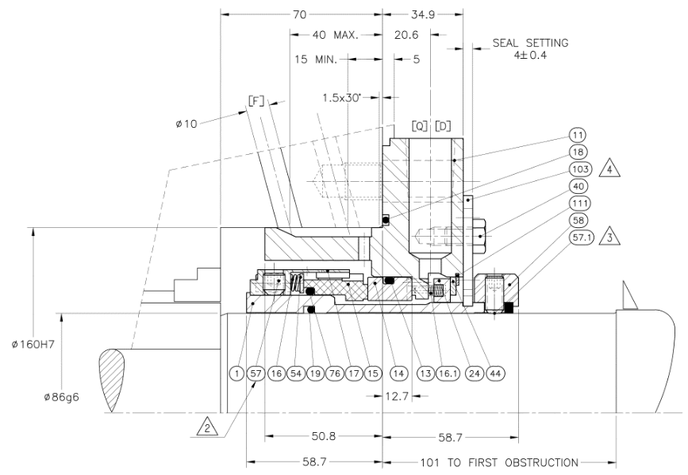

The Flowserve acceptance criteria are:
- An average seal leakage rate of 10cc/hour per seal face pair, after run in period during the charging mode of the pump. At start-up the average leakage may be 30 cc/hr
- No evidence of chipping or deterioration of the contact surfaces allowed.
- A maximum wear rate of 2.5x10-6 inch/hr (0.063 µm/hr) of the carbon seal faces.
- Seal able to re-cover to normal behavior after exposure to accidental condition.
- No severe damage to metal rotating seal parts; sleeve

Field Conditions

Seal type and size : QB-4000
Material code : 5AYZ
Pump fluid : Borated Water without solids (negligible content)
Seal chamber pressure : 2.96 Barg Min. / 3.15 Barg Normal / 3.6 Barg Max.
Seal chamber temperature : 15 ° C Min. / 50 ° C Normal / 105 ° C Max.
Speed : 1708 @ 57.5Hz rpm , 1485 @ 50Hz rpm
API-plan : 01, Flow rate 12 to 14 LPM
Flowserve order number : 873204NUC
Assembly drawing : D0355595 (Appendix I),HPC-UK6153-AU-PTR-DRL-100025

Test Conditions

Seal type and size : QB-4000
Material code : 5AYZ
Seal chamber fluid : Demin water
API-plan : 54
Test project number : 2017RSD11TL
Test assembly drawing : D0383396 rev. B (Appendix II)
Pressure : See chapter 7 Test program
Temperature : See chapter 7 Test program
Speed : See chapter 7 Test program

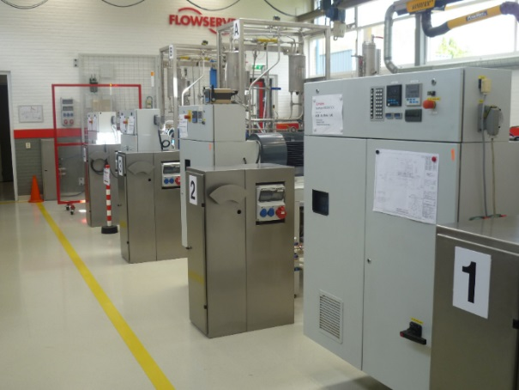
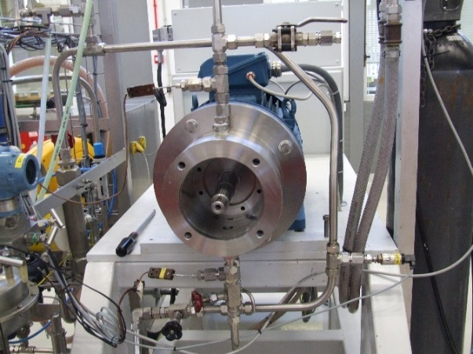

Figure1: Flowserve Seal Test Facility

Test Seal Configuration

Plug seal : QB-4000
Rotating Face : 154814GE
Material : Resin Impregnated Carbon Graphite
Stationary face : 668881SL
Material : Reaction Bonded Silicon Carbide
Gasket : Ethylene Propylene

Job seal : QB-4000
Rotating Face : 154814GE
Material : Resin Impregnated Carbon Graphite
Stationary face : 668881YO
Material : Self-Sintered Silicon carbide
Gasket : Ethylene Propylene, JS, PMUC Approved James Walker, Shieldseal 663

Test Set-up
The test will be executed on test rig no. A. This unit is equipped with a frequency driven motor. Seal will be built as per sketch below and drawing in Appendix II.
The test unit has been equipped with a pressurized circulation loop, equipped with a circulation pump, in order to create the required flowrate across the mechanical seal. An air driven piston pump will be used to control the pressure on the circulation loop. The temperature in the loop can be controlled by heating and /or cooling, using the installed electrical heater and/ or the water cooler(s). Thermo-couples installed in inlet and outlet piping will record the fluid temperature.
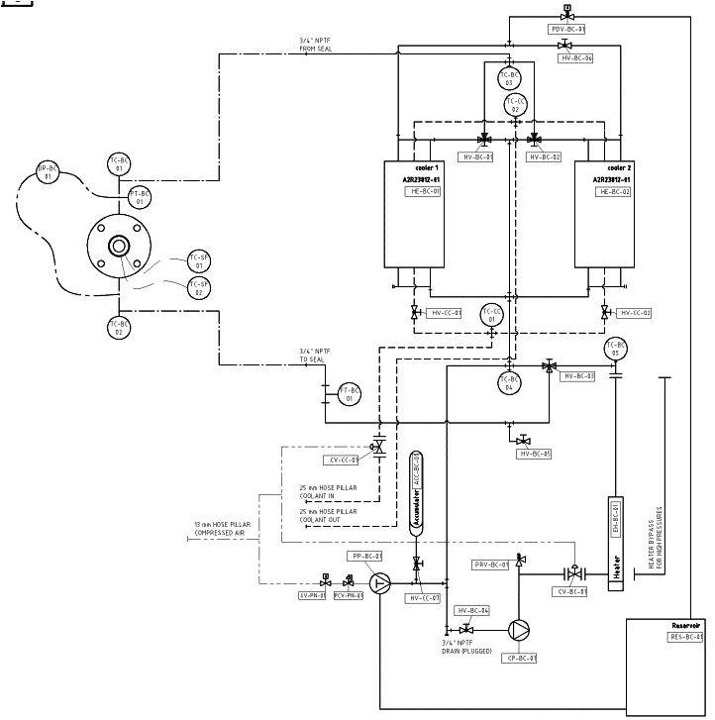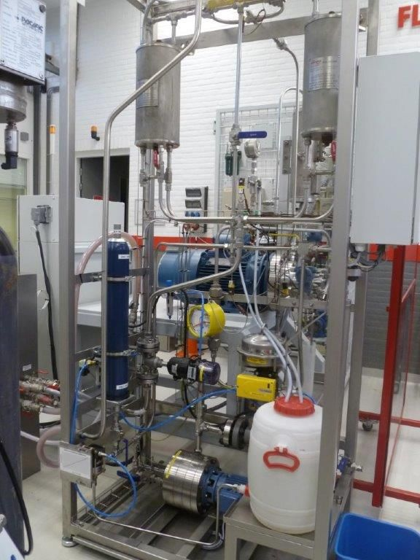
For more details, see the appendix III.

PRE-TEST WORK
- At first installation the alignment of the Seal chamber will be measured and recorded;
- Prior to first installation all mechanical seal and test components will be inspected for proper construction, compliance to drawing and material;
- Check seal faces for flatness. If not flat within two light bands, re-lap the faces;
- A surface profile of the "running area" of both, the rotating and stationary faces will be recorded as well as the face roughness (Ra value The carbon face height will be measured for future wear rate determination;
- The mechanical seal test cartridge will be assembled.
- The plan 54 system will be statically pressurized to the dynamic test pressure for a period of 10 minutes to check the tightness of the mechanical seal assembly.

DYNAMIC TEST

Hydrostatic Test
The mechanical seal will be hydro tested for tightness at a pressure of 30 Barg @ ambient temperature. Pressure will be increased in stages of 5 barg with duration of 15 minutes. Pressure will be decreased to atmospheric.

Running-in
The purpose of the running in test is to allow the seal faces to run in at moderate operating conditions at rated speed of 1750 rpm The test will be performed at low temperature (Ambient) and medium pressure of 10 barg, the pressure will be gradually increased to 10 barg. The seal will be allowed to run in for a period of 96 hours. The mechanical seal will be examined after completion of this test.

Characterization Test
This test is intended to demonstrate good seal behavior under normal, stable operating conditions. Test will be performed at rated speed of 1750 rpm. Test will be performed at 2 different temperatures; 35, 50 °C and 3 different pressures; 2, 15 and 28 barg. Duration of tests as per table in Test Summary. The mechanical seal will be examined after completion of this test.

Endurance Test
The endurance test will be performed under same conditions as the Characterization test, but will include 10 to 20 start-up/shutdown cycles, in order to accelerate seal ring wear to simulate aging. The mechanical seal will be examined after completion of this test.

Thermal Shock Test
The PTR pumps can be exposed to higher temperatures for short duration of time, for that reason a thermal shock test will be performed. This test will be performed on the basis of normal operating conditions of the PTR Pumps; 3 barg sealing pressure at 50 °C at speed of 1750 rpm. The hot shock will be simulated by sudden exposure to water at 105 ° C. This test will be repeated several times. The mechanical seal will be examined after completion of this test.

Test Summary
Phase | Test | Pressure (bar_{g}) | Temperature (°C) | Rotational Speed (rpm) | Duration | Comments
7.2.1. | Hydrostatic Test | 5  10  15  20  25  30  0 | ambient | 0 | 15 min  15 min  15 min  15 min  15 min  15 min | Total 1 h 30
7.2.2 | Running-in | 5  10 | ambient | 1750 | 48 h  48 h | Total 96h
7.2.2 | Examination | Duration 2 days, including test preparation 7.2.3
7.2.3 | Characterization Test | 2  15  28  2  15  28 | 35  50 | 1750 | 96 h  96 h  96 h  96 h  96 h  96 h | Total 576 h
7.2.3 | Examination | Duration 2 days, including test preparation 7.2.4
7.2.4 | Endurance test | 2  15  28  2  15  28 | 35  50 | 1750 | 48 h  48 h  48 h  48 h  48 h  48 h | stop/start at 20h and 40h running per sequence, total 12x stop/start. Total 288 h
 | Examination | Duration 2 days, including test preparation 7.2.5
7.2.5 | Thermal shock test | 3 | 50 | 1750 | 48 h | Thermal shock at 3 h @ 105 C  Thermal shock at 6h @ 105 C  Thermal shock at 28 h@ 105 C  Thermal shock at 32 h@ 105 C
 | Examination | Duration 2 days

MONITORING OF DYNAMIC TEST
Seal Performance, by means of a data acquisition system the following parameters will be recorded with an interval of 5 minutes:
- Water inlet temperature;
- Water outlet temperature;
- Water pressure.

By hand at regular intervals during day shift:
- Water inlet temperature;
- Water outlet temperature;
- Water pressure;
- Water flow rate;
- Leakage of mechanical seal as well as the plug seal;
- Power consumption.

POST-TEST WORK
- Directly after a test sequence is stopped the break-out torque will be measured under pressurized condition; This will be repeated 10 minutes after the first measurement;
- Drain seal and disassemble mechanical seal from test rig;
- The mechanical seal will be dismantled for inspection;
- Following parts will be inspected and observations recorded:
- Seal faces;
- Anti-rotating pins:
- A surface profile of the "running area" of both, the rotating and stationary faces will be recorded. The face roughness (Ra value) will be recorded in radial direction. In case of carbon face material; the face height will be measured for seal face wear rate determination;
- Photographs of both rotating and stationary faces will be made;
- If carbon face material is used the wear rate will be calculated.

REPORTING
- Every deviation from the test program will be recorded with a Test Program Change Notice (TCN);
- A detailed test report will be written after completion of the complete test program.

Planning

Test is scheduled to start in August2020, upon agreement between Flowserve and EDF.

Appendix I: HPC-UK6153-AU-PTR-DRL-100025

Appendix II

Appendix III

